 | Proving Ring, 6,000 lbs  Code: PR-60  Product Group: Additional Analog Proving Rings  (2,722 kg), 8.459" h.

Spares/Consumables
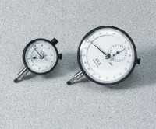 | Mechanical Dial Indicator - 0.2" Range  Code: 88-4000

