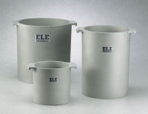 | Unit Weight Measure 1 cu. Ft. Capacity  Code: 34-2856  Product Group: Unit Weight Measures, Unit Weight Measures  1 cu. Ft. Capacity

Standards
ASTM C29

Specification
Construction | Cast aluminum; machined inside; with handles.
Top Rim | Machined smooth; parallel with bottom.
Inner Dimensions | 14 â (355 mm) i.d. x 11 .2â  (284.4 mm) inside h.
Weights | Net 26-1/2 lbs. (12 kg).

