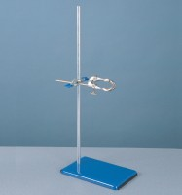 | Support Assembly  Code: 81-0094  Product Group: Stand, Bosshead and Clamp

Further Information
**NOT AVAILABLE FOR SALE IN THE USA**

