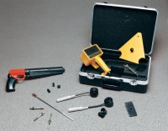 | Windsor HP Probe System  Code: 35-1450  Product Group: Windsor HP Probe System

Standards
ASTM C803

Further Information
Probe and Power Loads not included, order separately.

Specification
System Components | Drive unit, electronic measuring device, templates,  measuring caps, gauge plates and carrying case.
Weight | Net 18 lbs. (8.5 kg).
Probes (Optional) | Silver Kit, Gold Kit: For tests on concrete with strengths up to 17,000 psi (11 0 MPa). Probes are made of high strength alloy, heat treated and annealed to Rockwell C 48.

