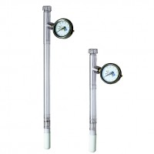 | Dial-Type Gauge Tensiometer 300 mm  Code: 514-020  Product Group: Tensiometers  300 mm Long

Further Information
Requires Part 514-034

