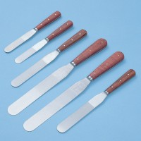 | Spatula 200 mm  Code: 81-0140  Product Group: Spatulas, Determination of Plastic Limit

Further Information
**NOT AVAILABLE FOR SALE IN THE USA**

