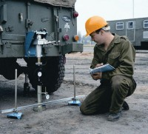 | Field CBR Test Set, Metric  Code: 2401E  Product Group: Field CBR  Set Includes:  EI24-9290. Field CBR Jack x 1  EI24-9300. Ball Seating Attachment x 1  EI78-0460. Proving Ring, 2,250 lb. (10 kN) cap. x 1  EI78-0760. Proving Ring, 6,000 lb. (28 kN) cap. x 1  EI24-9183. Field Penetration Piston x 1  EI24-9308. Extension Rod x 1  EI24-9188. Bracket and Adapter x 1  EI24-9312. Bridge Support x 1  EI88-4110. Penetration Dial Indicator x 1  EI24-9245. Circular 5 lb. (4.54 kg) Surcharge Weight x 1  EI24-9246. Slotted 10 lb. (4.54 kg) Surcharge Weight x 1  EI24-9248. Slotted 20 lb. (9.07 kg) Surcharge Weight x 1.

Standards
ASTM 4429

