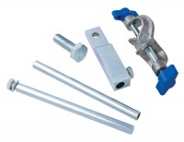 | Bracket and Adaptor. Dual Purpose Mounting Bracket for CBR Penetration Gauges EL24-9184/EL24-9186  Code: 24-9188  Product Group: In-situ CBR, Conversion of In-situ to Laboratory CBR, Penetration and measurement  Dual purpose mounting bracket for CBR penetration dial gauges. Allows gauge to be fixed to penetration piston or load ring.

