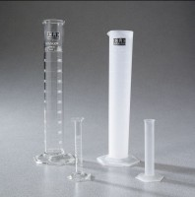 | Glass Graduated Cylinder - 25 ml Capacity  Code: 88-6002A  Product Group: Glass Graduated Cylinders  25 ml capacity x 0.2 ml divisions.  Net Wt. 2 oz. (56 g).

Specification
Numbering | Double; with zero at top and bottom.
Packing | 1 cylinder/carton.

