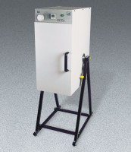 | ELE Rotasift Laboratory Sifter 110V  Code: 80-0417/02  Product Group: ELE Rotasift Laboratory Sifters  110vAC, 60 Hz, 1ø.

Specification
Capacity | Ten 8â (203 mm) or six 12 â (305 mm) diameter sieves plus cover.
Timer | Built-in 30 minute.
Motor | 1/3 h.p.
Dimensions | 19.9â w. x 30.7â d. x 59â h. (505 x 780 x 1,500 mm). Width and depth dimensions are the base dimensions of the frame.
Weight | Net 175 lbs. (79.4 kg).

