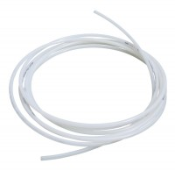 | Nylon Tubing 30 Metre Length.  Code: 26-1769  Product Group: Air/Water Pressure Systems - up to 1000 kPa  30 metre length. For pressures up to 1700 kPa. Used for connecting Air Compressors to Pneumatic Pressure Reducing Panels, or for connecting two Pressure Reducing Panels together.

Further Information
Nylon tubing 30 metres with pressure fittings.

