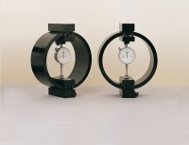 | Clamped Boss Load Ring - 4.5 kN  Code: 78-0260  Product Group: Clamped Boss Load Rings, Digital Tritest 50 Load Frame, Direct/Residual Shear Apparatus, Proving Rings, Load Measurement, Load Measurement, Load Measurement

Specification
Capacity: kN, kgf, lbf | 4.5, 450, 1000
Typical Design sensitivity: N/div, kgf/div, lbf/div | 3.0, 0.30, 0.66
Overall height mm | 248
Approx weight kg | 3.5
Capacity - lbf | 1,000
Capacity - kN | 4.5
Capacity - kgf | 450
Typical Design Sensitivity - lbf/div | 0.66
Typical Design Sensitivity - kN/div | 3
Typical Design Sensitivity - Kgf/div | 0.3
Overall Height | 9.76” (248 mm)
Approx Weight | 7.7 lbs.(3.5 kg)

Spares/Consumables
 | Spare Dial Indicator for Load Rings  Code: 78-5461

