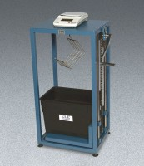 | ELE Buoyancy Balance  Code: 34-8100/02  Product Group: ELE Bouyancy Balance

Further Information
110-120vAC, 50/60 Hz, 1ø.

Specification
Frame | Heavy-duty steel frame construction with  mechanical lifting device and suspension hook.
Water Tank | 15 â w. x 9.5â d. x 11 â h. (380 x 24 0 x 280 mm).
Balance | Electronic; 22 kg capacity x 0.1 g.
Weight | Net 93 lbs. (42 .1 kg).

