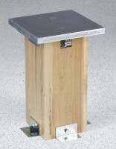 | Compaction Pedestal  Code: 45-6416  Product Group: Compaction Pedestal

Standards
ASTM D6926, AASHTO T245

Specification
Top Plate | Plated steel; 12 â x 12 â x 1â thick (305 x 305 x 25 .4 mm).
Base | Laminated hardwood.
Installation | 4 angle brackets for mounting to concrete slab.
Dimensions | 8â w. x 8â d. x 18â h. (203 x 203 x 457 mm).
Weight | Net 74 lbs. (33.6 kg).

