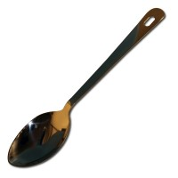 | Density Spoon.  Code: 29-5000  Product Group: Field density tools  For removing soil from the hole

