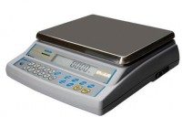 | Electronic Balance - 75 000 g x 20.0 g  Code: 78-5666/01  Product Group: Electronic Balances

Further Information
**Not available for sale in the USA**

Specification
Capacity resolution | 75000 g x 20.0 g
Pan size | 310 x 300 mm
Mains and battery | Yes
Dimensions (l x w x h) | Base 300 x 310 x 50 mm, Indicator 80 x 270 x 30 mm
Weight | 5 kg

