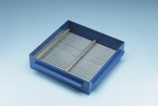 | Grid Sieve 8mm Slot Width for EN Aggregate Flakiness Test.  Code: 42-0310  Product Group: Grid Sieves  8mm

Standards
EN 933-3

Further Information
**NOT AVAILABLE FOR SALE IN THE USA**
Passing Size - 16 mm Retained Size - 12.5 mm

