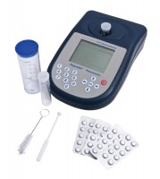 | Paqualab Photometer Complete with Six Test Tubes Dilution Tube Operating Manual and Carrying Case.  Code: 430-550  Product Group: Paqualab Test Meters  Comprising photometer unit as described with built-in filters, dilution tube, six glass test tubes, operating instructions and moulded plastic carrying case with space to hold up to four different reagent systems.

Further Information
Test reagent tablets are not supplied.

