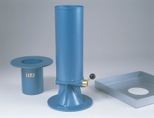 | 200mm Calibrating Container 200mm Id X 250mm Deep with A 350mm Dia Rim.  Code: 29-4220  Product Group: Sand Replacement

Standards
BS 1377, BS 1924

