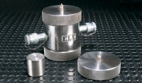 | Pair of Permeability End Caps Nx. Supplied with Distance Block.  Code: 70-1750  Product Group: Permeability of Rock  Permeability end caps used with ELE-Hoek Cells and constant pressure systems are a cost-effective solution suited to investigating the permeability of rock at high confining pressures in the laboratory.  To collect and measure the water which permeates through the rock specimen, a suitable burette such as 25-4540 is recommended. Each permeability end cap incorporates a tubing connector which accepts standard 6 mm tubing, 26-1926, used to connect the cell to the pressure system and burette.

