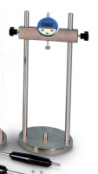 | Length Comparator  Code: SP34-8501  Product Group: Measuring Equipment  Used to measure the length variations of mortar specimens after autoclave soundness tests. The top beam is adjustable to suit the specimen's length.  It also measures the linear shrinkage of specimens having different dimensions such as 40 x 40 x 160 mm or 25 x 25 x 250 mm.  Supplied with Digital Gauge, 15.3 mm travel by 0.001 mm divisions complete with battery.

Standards
ASTM C348, ASTM C490, EN 12617-4, EN 12808-4

