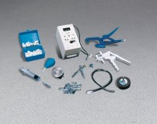 | Concrete Permeability Test System  Code: 35-4050  Product Group: Concrete Permeability Test System (Porouscope)

Specification
Power Supply | Standard 9V battery
Weight | 12 lbs (5.4 kg)

