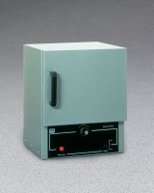 | Double Wall Laboratory Oven - 0.7 cu. Ft. Capacity - 115vAC  Code: 88-0200/02  Product Group: Double Wall Laboratory Ovens  115vAC, 50/60 Hz, 1ø.

Specification
Capacity | 0.7 cu. ft. (19.8 liter).
Chamber Size | 12 â w. x 10â d. x 10â h. (305 x 254 x 254 mm).
Temperature Range | 225 Â°C (43 7Â°F) maximum.
Shelves | Two included.
Thermometer | One included.
Overall Dimensions | 14 â w. x 12 â d. x 17â h.  (35 6 x 305 x 432 mm).
Weights | 41 lbs. (18.6 kg).

