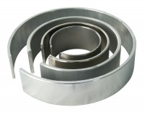 | Membrane Placing Tool 35mm/38mm.  Code: 25-4290  Product Group: Membrane Placing Tools, O-Ring Placing Tools  Membrane Placing Tool For 35Mm/1.4 Inch And 38Mm/1.5 Inch Samples.

Standards
ASTM D2850, ASTM D4767, ASTM D5084, AASHTO T296, AASHTO T297

