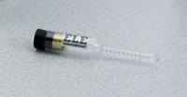 | Concrete Air Indicator Kit  Code: 34-3280  Product Group: Concrete Air Indicator Kit

Standards
AASHTO T199

Spares/Consumables
 | Concrete Air Indicator  Code: 38-3280/10

