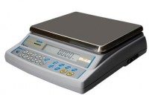 | Electronic Balance - 4 500 g x 0.01 g  Code: 78-5456/01  Product Group: Electronic Balances

Further Information
**Not available for sale in the USA**

Specification
Capacity resolution | 4500 g x 0.01 g
Pan size | 160 x 160 mm
Mains and battery | No
Dimensions (l x w x h) | 260 x 170 x 90 mm
Weight | 6 kg

