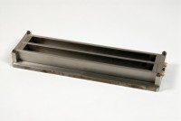 | Two Gang Prism Mould Produces 1 Inch Square X 11 1/4 Inch Long Specimen (10 Inch Gauge Length)  Code: 34-8544  Product Group: Test Bar Moulds, Prism Moulds and Inserts  To produce specimens 1 inch square x 11¼ inches long to ASTM C490. The mould is constructed so that the gauge length can be set within ± 0.1 inch limits.

Standards
ASTM C141, ASTM C151, ASTM C157, ASTM C227, ASTM C490, ASTM C531, AASHTO T107

Specification
Construction | Plated steel.
Gauge Length | 10â (254 mm) between inner ends of embedded contact points.
Weight | Net 20 lbs. (9.1 kg).

