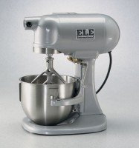 | Mortar Mixer, 115V  Code: 39-0075/02  Product Group: Mortar Mixer, 5 Qt.  Includes stainless steel 5 qt. (4.73 liter) bowl, bowl clearance adjustment bracket and stainless steel beater. ASTM compliant.

Standards
ASTM C305, AASHTO T162

Further Information
115vAC, 60 Hz, 1ø.

Specification
Capacity | 5 qts. (0.167 ft, 4.73 liters).
Motor | 1/6 h.p.; 124 Watts.
Speeds | Low, intermediate, and high; 139, 285 and 591 rpm.
Mixing | Planetary action.
Bowl | Stainless steel; with clearance adjustment  bracket.
Beater | Flat-type; stainless steel.
Dimensions | 10-3/8â x 12 -1/4â x 17â h. (263 x 311 x 432 mm).
Weight | Net 50 lbs. (22.7 kg)

Spares/Consumables
 | Stainless Steel Beater  Code: 39-0075/12
Stainless Steel Bowl
Code: 39-0075/10

