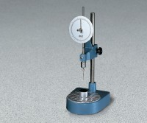 | Standard Penetrometer  Code: 46-5290  Product Group: Penetration Test, Bitumen Penetration Test, Asphalt Penetrometer  Penetration readings are quickly taken using this simple to operate apparatus. The 150 mm diameter dial is graduated in 400 divisions of 0.1 mm. Supplied without needles and penetration tins.

Standards
BS 2000-49, EN 1426, EN 13179-2, IP 49, ASTM D5, AASHTO T49

Further Information
Model shown with sample container; not included, order separately.

Specification
Dial Indicator | 6” (150 mm) diam.; 400 mm x 0.1 mm.
Plunger Weight | 47.5 g.
Needle | ASTM Style (non-certified); one included.
Plunger Release | Manual mechanism.
Weight | Net 18 lbs. (8.2 kg).

Spares/Consumables
 | ASTM (Non-Certified) Penetration Needle  Code: 46-5290/10

