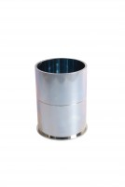 | Compaction Mould  Code: 45-6310  Product Group: Accessories for manual and automatic compaction, Asphalt Compaction Mould  Comprising of mould body, baseplate and combined filling/extraction collar.

Standards
EN 12697-30, ASTM D6926, AASHTO T245

Specification
Construction | Machined seamless steel forming mold;  base and collar.
Finish | Plated for rust resistance.
Dimensions | 4” (101.6 mm) i.d. x 3” (76.2 mm) internal  h. with base.
Weight | Net 6 lbs. (2.7 kg).

