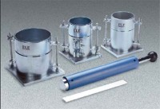 | Modified Compaction Mould  Code: 24-9098  Product Group: Modified Compaction Mould, Automatic Soil Compactor  1/13.33 cu.ft.; 6” i.d. x 4.584” h.

Standards
ASTM D698, ASTM D1557, AASHTO T99, AASHTO T180

Specification
Mould Volume | 1/13 .33 cu. ft.
Dimensions | 6â i.d. x 4.584â h. (152 .4 x 11 6.4 mm).
Base Plate | 8â x 8â (203 x 203 mm).
Weight | Net 18 lbs. (8.2 kg).

