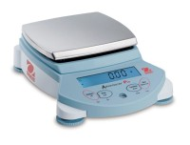 | Ohaus Electronic Balance - 2,100 g Capacity  Code: 88-1044/02  Product Group: Ohaus Series Electronic Balances  Includes weigh-below hook.

Further Information
100-240V, 50/60 Hz.

Specification
Maximum Capacity | 2100 g
Readability | 0.01 g
Repeatability (Std. Dev.) | 0.01 g
Linearity | +/-0.02g
Internal Calibration | NO
Pan Size (in/cm) | 6.6 X 7.1 /  16.8 X 18
Dimensions w x h x d (in/cm) | 8.7 x 7.5 x 11 .8 /  22 x 19  x 30
Shipping Wt. (lb/kg) | 12 .6 / 5.7

