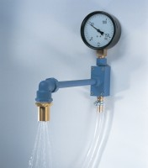 | Spray Nozzle Apparatus  Code: 38-7600  Product Group: Fineness of Fly Ash (Wet Sieving)  Comprising a spray nozzle 17.5 mm ID with 17 holes as specified in EN451, a vacuum pressure gauge, 160 kPa graduated at 5 kPa divisions and fittings to attach the apparatus to a standard domestic water supply. Supplied without sieve.

Standards
BS 3892-1, EN 451-2, ASTM C430

Further Information
**NOT AVAILABLE FOR SALE IN THE USA**

