 | 1/2" Extension Point  Code: 88-4152  Product Group: Mechanical Dial Indicators  1/2” (13 mm) Extension Point.

Spares/Consumables
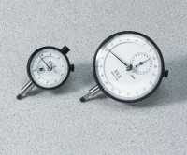 | Dial Indicator - 1.0" Range  Code: 88-4100
Mechanical Dial Indicator - 0.2" Range
Code: 88-4000

