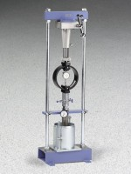 | CBR Loading Press, Hand-Operated  Code: 24-9345  Product Group: CBR Loading Press, Hand-Operated

Standards
ASTM 1883, AASHTO T193

Specification
Jack | Mechanical; with quick release device for rapid adjustments.
Frame | Heavy-duty steel construction with two column uprights.
Dimensions | 14 .5â w. x 10.25 â d. x 46â h. (368 x 260 x 1,168 mm).
Weight | Net 145 lbs, (65.7 kg).

Spares/Consumables
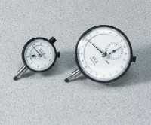 | Dial Indicator - 1.0" Range  Code: 88-4100

