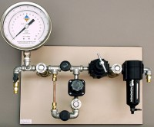 | Low to High Pressure Manifold Compression Type  Code: 532-128  Product Group: Pressure plate extractors  To regulate pressure from compressor to extractor.

