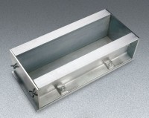 | Heavy-Duty Beam Forms  Code: 34-5057  Product Group: Heavy Duty Beam Forms  Net 73 lbs. (33 kg).

Standards
ASTM C31, ASTM C78, ASTM C192, AASHTO T23, AASHTO T97, ASTM T126

Further Information
For 6" x 6" x 24" Beams

