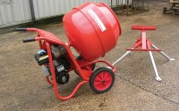 | Tilting Drum Concrete Mixer 120/90L/ (4/3Cu.Ft) Complete with Stand  Code: 34-3590/01  Product Group: Tilting Drum Mixer  120/90 litre mixing capacity. For 220 - 240 V AC, 50 Hz, 1 ph.

Further Information
**NOT AVAILABLE FOR SALE IN THE USA**

