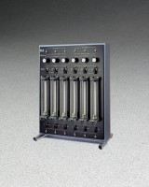 | Auxiliary Control Panel  Code: 25-0699  Product Group: Tri-Flex 2 Auxiliary Control Panel, Tri-Flex 2 Master Control Panel  For two additional triaxial cells

Standards
ASTM D2850, ASTM D4767, ASTM D7181, ASTM D5084, AASHTO T296, AASHTO T297

Further Information
Tri-Flex 2 Master Control Panel required for operation.

Specification
Measurement Range | 10-4 to 10-10 cm/sec.
Burette Pressure Regulators | Six; 2 to 15 0 psi (14 -1,034 kPa).
Burette/Annulus | Six; 25 /400 ml capacity with 0.1 ml burette graduations.
Utilities Required | Water, vacuum, Dry air pressure and drain  through connection to the Master Control Panel.
Dimensions | 27â w. x 36-3/4â h. x 7â d. (17â d. With legs); (686 x 933 x 178 mm).
Weight | Net 80 lbs. (36.3 kg).

