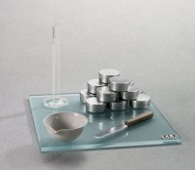 | Plastic Limit Set  Code: 2810E  Product Group: Plastic Limit Set  Set includes:  1 Plastic Limit Plate (24-0810) 12” x 12” x 3/8”.  1 25 ml Graduated Cylinder (88-6002A).  1 Mixing Dish (88-6710).  1 Doz. Aluminum Moisture Cans (88-7002).  1 Flexible Spatula (88-7500).  1 Rod Comparator (24-0811).

Standards
ASTM D4318, AASHTO T90

