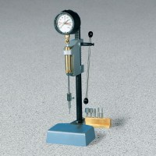 | Acme Laboratory Penetrometer  Code: 38-2670  Product Group: Acme Laboratory Penetrometer  Includes one package of data sheets.

Standards
ASTM C-403, AASHTO T197

Specification
Capacity | 200 lbf. (890 N).
Operation | Hydraulic.
Needles | 6 included; 1/40, 1/20, 1/10, 1/4, 1/2 and 1 sq. in. end areas; stored in wooden block holder.
Weight | Net 29.2 lbs. (13.2 kg).

