 | Paqualab lightweight System 25L for analysis of drinking water to EC Staandard Categories 1 & 2  Code: 418-100  Product Group: Paqualab Standard Systems  Including the incubator 25L, conductivity/temperature/mV meter, turbidity tube 5 - 500 JTU, ELE Paqualab photometer and consumables for 200 tests on faecal or total coliforms, chlorine and pH.

Further Information
Includes a lightweight carrying case, dimensions 380 x 180 x 230 mm.

Spares/Consumables
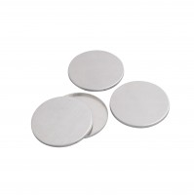 | Aluminium Petri Dishes Pack of 25.  Code: 422-560
Coliform Starter Pack. Sufficient for 200 Tests
Code: 422-010
Filtration Unit Al Construction Complete with Sampling Cup.
Code: 420-450
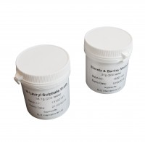 | Membrane Lauryl Sulphate Medium 38.1 Gram Pack. Sufficient for 200 Tests.  Code: 422-110
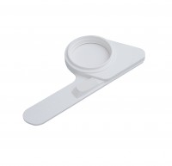 | Pad Dispenser.  Code: 422-515
Sterile Filter Membranes and ABSorbent Pads. Pack of 200.
Code: 422-508

