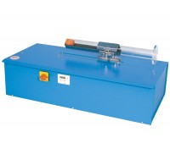 | Motorised Sand Equivalent Shaker ASTM. 220-240V 50Hz 1Ph.  Code: 24-4945/01  Product Group: Sand Equivalent Value, Sand Equivalent Value  Bench mounting mechanical sand equivalent shaker with a stroke of 203mm (8 inches) and a running frequency of 175 cycles per minute. The integral timer stops shaker upon test completion. For use on 220-240v 50hz 1ph.

Further Information
**NOT AVAILABLE FOR SALE IN THE USA**
Recommended for use in laboratories performing a large number of tests, motorised shakers provide a consistent and repeatable oscillation, minimising variation in test results.

