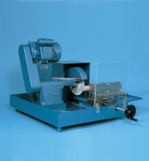 | Gsp210/250 Core Trimmer & Cut Off Machine Supplied with Coolant Pump Unit  Code: 70-0250/01  Product Group: Sample Preparation  This unit, designed for use in Rock Mechanics, can also be used in mineralogy, ceramics and refractory sample preparation. Cores in excess of 140 mm length and cubes up to 100 mm square can also be prepared.

Further Information
Supplied complete with coolant recirculation pump/tank unit and 1 each diamond set cutting disc and
double faced cup wheel. For 220 – 240 V AC, 50 Hz, 1 ph.

Specification
Dimensions (l x w x h) | 406 x 915 x 760 mm
Two vices supplied | 1- Regular and Irregular samples up to 70 x 125 mm  1- V-vice cores up to 57 mm diameter x 140 mm long
Blade capacity | 200 mm
Rated Power | 750 W
Weight | 118 kg

