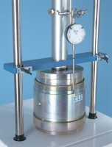 | Cbr Penetration Piston (Adjustable).  Code: 24-9183  Product Group: In-situ CBR, Conversion of In-situ to Laboratory CBR, Penetration and measurement  As 24-9182 but with a coarse stem adjustment. This piston is particularly useful for in-situ testing.

