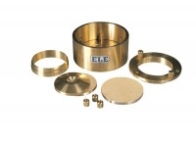 | Cutting Ring 75mm Cell.  Code: 25-0506  Product Group: BS EN consolidation cells and accessories, Fixed Ring Consolidation

Standards
BS 1377, EN 1997-2

