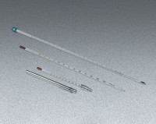 | Glass Laboratory Thermometer, -20° to 110°C x 1.0°; 12” (305 mm) l.  Code: 88-4480NT  Product Group: Glass Laboratory Thermometers  Non-Toxic

Specification
Weight | Net 3 oz. (85 g).

