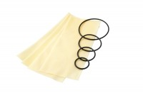 | Membrane Sealing Ring 50mm Diameter Pack of 10.  Code: 25-5461  Product Group: Membrane Sealing Rings, Sealing Rings  50 mm diameter membrane sealing ring (Pack Of 10).

