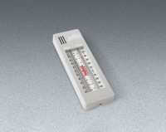 | Dual-Scale, Maximum-Minimum Thermometer  Code: 88-4612  Product Group: Dual-Scale, Maximum-Minimum Thermometer

Specification
Ranges | -30Â° to +120Â°F and -35Â° to +50 Â°C
Dimensions | 8-3/4â x 2-3/4â (222 x 70 mm).
Weight | Net 6 oz. (168 g).

