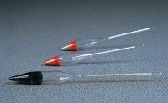 | Soil Hydrometer BS EN DD ENV graduated 0.0995 to 1.030 g/ml  Code: 24-4620  Product Group: Soil Hydrometers  Graduated 0.0995 to 1.030 g/ml.

Standards
ASTM D422, BS 1377, EN 1997-2, ASTM E100, AASHTO T88

